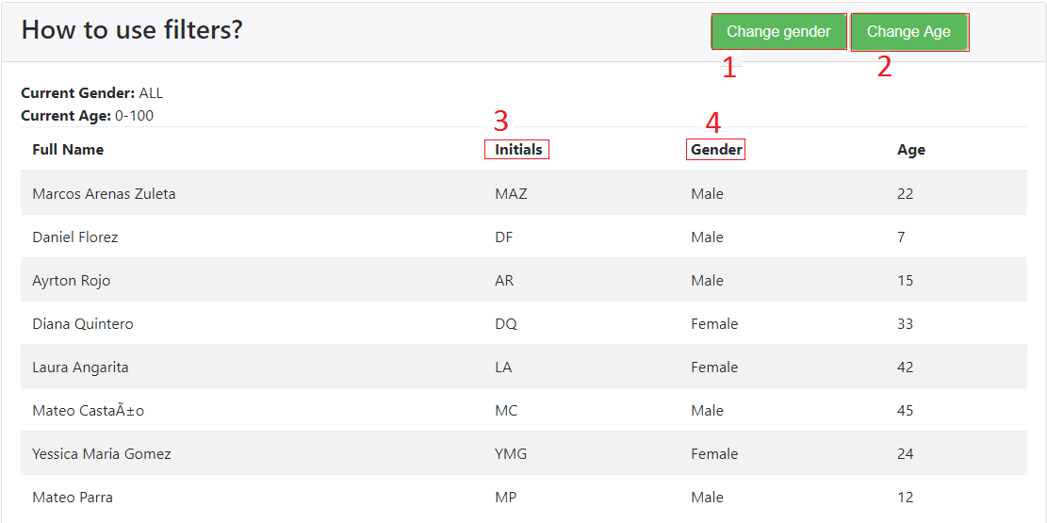

Instructions:

* Create a constant which contains a JSON with the following structure:

Angular.module(‘app’).

constant(‘EXAMPLE’, [

{

fullName:String,

gender: M / F,

age: numeric

},…….

]

* + Is important to set only M or F in the gender.
* Create a component that contains a table and two buttons, the table will be filled with our constant
* The table has 4 columns: Full Name, Initials, Gender and Age
* Create 4 filters
  + The first filter is for the initials, it receives the full name and returns only the initials in upper case
  + The second filter is for the gender, it receives the gender (M / F) and returns the whole word (Male / Female)
  + The third filter is for the first button (Change gender): this button is going to change our current gender ( ALL -> M -> F -> ALL), fill the table depending on the current gender.
  + The fourth filter is for the second button (Change age): This button is going to change our current age range ( 0-100 -> 0-10 -> 10-20 -> 20-30 -> 30-40 -> 40-50 -> 0-100), fill the table depending on the current age range.